Model Validation — Statistical & Quantitative Finance
Separating a Genuine Edge From an Artefact of the Data
From Train/Test Splits to Walk-Forward Testing: Determining Whether a Model Actually Works
A Level 2 module in the Quantitative Finance Curriculum — revisited at Level 5
Covers: in-sample vs out-of-sample testing · train/validation/test splits · cross-validation · walk-forward validation · time-series cross-validation · backtesting · look-ahead bias · data leakage · survivorship bias · selection bias · overfitting · underfitting · benchmark models · statistical significance · confidence intervals · bootstrap validation · permutation tests · parameter stability · sensitivity analysis · robustness testing · model decay · out-of-sample performance

Table of Contents
How to Use This Guide
What You Need to Know Before Starting
Understand Before Proceeding
Why It Matters
How This Connects to the Rest of the Curriculum
Glossary of Recurring Terms
Part 1 — In-Sample vs Out-of-Sample Testing
1.1 In-Sample and Out-of-Sample Performance
1.2 Train, Validation, and Test Splits
1.3 Overfitting and Underfitting
Part 2 — Validation Schemes for Time-Series Data
2.1 Why Standard Cross-Validation Fails on Time Series
2.2 Walk-Forward Validation
2.3 Time-Series Cross-Validation, Purging, and Embargo (awareness)
Part 3 — Biases That Corrupt a Backtest
3.1 Look-Ahead Bias
3.2 Data Leakage
3.3 Survivorship Bias and Selection Bias
Part 4 — Statistical Validation: Significance and Resampling
4.1 Statistical Significance and Confidence Intervals
4.2 Bootstrap Validation
4.3 Permutation Tests
Part 5 — Benchmarks, Stability, and Robustness
5.1 Benchmark Models
5.2 Parameter Stability and Sensitivity Analysis
5.3 Robustness Testing
Part 6 — Multiple Testing, Model Decay, and Ongoing Validation
6.1 Multiple Testing and Data-Snooping (awareness)
6.2 Model Decay and Out-of-Sample Performance
Practical Exercise
Common Beginner Mistakes
Advanced Extensions
Professional Applications
Where to Go Next

How to Use This Guide
This document is a companion to Model Validation — Statistical & Quantitative Finance, the module that stands between a promising backtest and a decision to trade real capital. Every other module in this curriculum is about building something — a forecast, a portfolio, a risk model. This module is about the single question that determines whether any of that work is worth trusting: did the model learn something real, or did it simply learn the noise, quirks, and unintended information contained in one particular historical dataset?
The module is self-contained: every concept is introduced from first principles, paired with a worked numerical example, and illustrated with a chart or diagram wherever a picture makes the idea land faster than prose. Read it start to finish if validation is new to you, or jump straight to the section you need — but do not skip Understand Before Proceeding below.

What You Need to Know Before Starting
- Statistics — hypothesis testing, p-values, and the general logic of inferring a population property from a sample.
- Probability — random variables, distributions, and expected value, since validation is fundamentally about distinguishing signal from sampling variation.
- Regression & Statistical Learning — the concept of a model fit to data, and why a model's fit to its own training data is not the same as its ability to generalise.
- Time-Series Analysis — autocorrelation and the idea that consecutive observations in financial data are not independent, which is central to why standard validation techniques need adapting.
- Risk Metrics — Sharpe ratio, drawdown, and volatility, since these are the quantities most often being validated.
- Basic Programming — enough to implement a chronological data split, a resampling loop, or a simple backtest.

Understand Before Proceeding
Prerequisite gate — A backtest is not evidence of profitability by itself.
Validation must reproduce the information actually available at the time each decision would have been made, and it must account for multiple testing, transaction costs, parameter instability, and changing market regimes. A backtest that gets any one of these wrong can look excellent while having no real-world predictive value at all — and the failure will not announce itself; the equity curve will simply look good until the strategy is trading real money. Everything in this module is deliberately at awareness depth for the harder statistical-inference topics (Combinatorial Purged Cross-Validation, the Probability of Backtest Overfitting, the Deflated Sharpe Ratio, and related multiple-testing corrections) — enough to reason correctly about why naive validation overstates performance, but not enough to safely build a production model-approval framework. That requires the Depth 3+ treatment of this same material.

Why It Matters
Model validation is the main defence a quantitative research process has against false discoveries. Financial data is noisy, historical samples are finite, and researchers — with the best of intentions — routinely try dozens or hundreds of variations of a model before settling on the one that looks best. Every one of those choices, made with knowledge of how earlier variations performed, subtly leaks information from the test period back into the model. Without rigorous validation, this process reliably manufactures strategies that look profitable on historical data and are not profitable, or are far less profitable, going forward.
The practical stakes compound quickly. A model approved on the strength of an in-sample backtest, or a backtest with subtle look-ahead bias or data leakage, can pass every internal review and still lose money from the day it goes live — not because markets changed, but because the apparent edge was never there. Proper validation is not a bureaucratic formality bolted onto the end of research; it is the process that determines whether the preceding weeks or months of model development produced something real.

How This Connects to the Rest of the Curriculum
- Research — Model validation is the critical gate between model development and deployment. It determines whether an observed signal survives unseen data, different market conditions, and reasonable changes to modelling assumptions, rather than being an artefact of one specific sample.
- Development — Validation must be reproducible and separated from model-training code to prevent accidental leakage. Production-quality research infrastructure should enforce chronological data splits, version datasets and parameters, and maintain consistent evaluation metrics across every model that goes through the pipeline.
- Trading — Traders rely on validation to determine whether a model's signals, forecasts, and risk estimates are sufficiently robust for live capital. Out-of-sample performance, turnover, drawdown, capacity, and execution costs all feed into whether a strategy can survive actual trading conditions, not just a spreadsheet.

Glossary of Recurring Terms
In-sample performance — How well a model fits or predicts the same data that was used to build or tune it — usually optimistic and never sufficient evidence of a real edge on its own.
Out-of-sample performance — How well a model performs on data it did not see during development — the closest available proxy for how it would have performed live.
Cross-validation — A family of techniques that repeatedly split data into training and testing subsets to estimate out-of-sample performance more reliably than a single train/test split.
Walk-forward validation — A validation scheme for time-ordered data in which the model is repeatedly retrained on all data up to a point and tested on the period immediately following, rolling forward through history.
Look-ahead bias — An error in which information that would not actually have been available at the time of a decision is used to make that decision in a backtest.
Data leakage — Any pathway, often subtle, by which information from outside the training set (commonly the test set, or the future) influences model training or feature construction.
Survivorship bias — A distortion that arises when a historical dataset includes only entities (funds, companies, securities) that still exist today, silently excluding those that failed or were delisted.
Selection bias — A distortion that arises when the sample used for research is not representative of the population the model will actually be applied to, because of how it was chosen.
Overfitting — Building a model complex enough, or tuned closely enough, to fit noise specific to the training sample, at the cost of performance on new data.
Underfitting — Building a model too simple or too lightly tuned to capture the genuine structure present in the data, leaving performance on the table on both training and test data.
Benchmark model — A simple, well-understood point of comparison (e.g., a naive forecast, a market-cap-weighted index, or a random strategy with the same risk) against which a new model's added value must be judged.
Statistical significance — A measure of how unlikely an observed result would be if there were, in truth, no real effect — used to judge whether an apparent edge could plausibly be due to chance alone.
Confidence interval — A range of plausible values for an unknown quantity (such as a true Sharpe ratio), constructed so that it would contain the true value a specified percentage of the time under repeated sampling.
Bootstrap — A resampling technique that repeatedly draws new samples, with replacement, from the observed data to approximate the sampling distribution of a statistic without assuming a particular theoretical distribution.
Permutation test — A resampling technique that repeatedly shuffles or randomises data to build a distribution of a statistic under the assumption that there is no genuine relationship, against which the actual observed statistic is compared.
Model decay — The tendency of a model's live or out-of-sample performance to deteriorate over time relative to its original backtest, often due to changing market regimes, crowding, or the erosion of the original edge.

Part 1 — In-Sample vs Out-of-Sample Testing
Every validation technique in this module is a variation on one idea: measure a model's performance on data it did not use to learn. This part introduces that idea directly, covers the standard way of carving up a dataset to make it possible, and explains the failure mode — overfitting — that validation exists to catch.

1.1 In-Sample and Out-of-Sample Performance
In-sample performance measures how well a model fits or predicts the very data used to build it — to estimate its parameters, choose its features, or tune its settings. Out-of-sample performance measures the same thing on data the model never saw during that process. The gap between the two is the single most informative number in model validation: a small gap suggests the model captured something genuine; a large gap suggests it captured noise specific to the training sample.
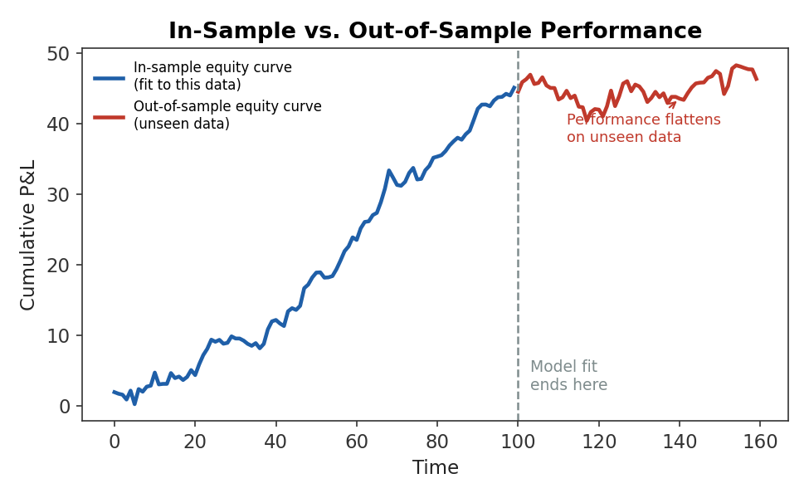
Figure 1.1 — An equity curve fit closely to in-sample data (blue) can diverge sharply once the model is applied to genuinely unseen, out-of-sample data (red) — the gap between the two is the signature of overfitting.
This gap is unavoidable to some degree — a model will almost always look slightly better on the data it was tuned on than on fresh data, simply because tuning is, by construction, a process of adapting to whatever patterns are present in the training sample, real or coincidental. The question validation answers is not whether this gap exists, but whether it is small enough, and the out-of-sample performance strong enough in absolute terms, to justify believing the model has found something real.
Common mistake — Reporting in-sample performance as evidence that a model works.
A Sharpe ratio, hit rate, or R² computed on the same data used to fit the model tells you how well the model memorised that data, not how it will perform going forward. This is true even for simple models with very few parameters, and becomes dramatically more true as model flexibility increases — a sufficiently flexible model can achieve near-perfect in-sample performance on pure noise, with zero genuine predictive content.

1.2 Train, Validation, and Test Splits
In practice, a dataset is typically divided into three chronological segments, each serving a distinct role. The training set is used to fit model parameters directly. The validation set is used to make higher-level decisions — choosing between candidate models, tuning hyperparameters, or deciding when to stop training — decisions that are still, in effect, a form of fitting to that data, just at one remove. The test set is used exactly once, at the very end, to produce a final, honest estimate of out-of-sample performance, and is never used to make any decision that feeds back into the model.
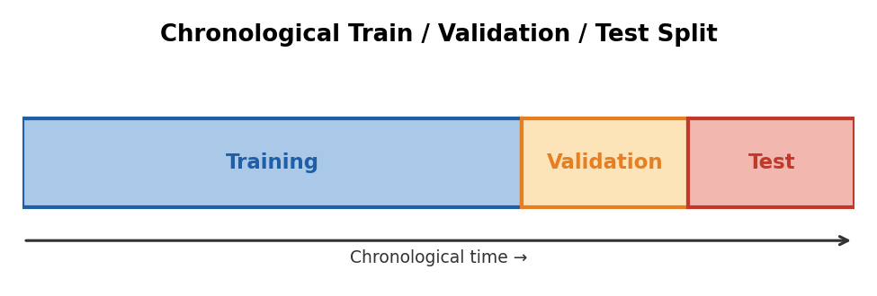
Figure 1.2 — A standard chronological split: the model is fit on the training segment, tuned and compared against alternatives on the validation segment, and evaluated exactly once, at the end, on the test segment.
Worked example — Why the validation set is not a free pass.
A researcher tries 50 different feature combinations, checking each one's performance on the validation set, and keeps the single best-performing combination. Even if every one of those 50 combinations were pure noise with no real predictive power, simple probability guarantees that a handful will look good on the validation set purely by chance — and the researcher will have unknowingly selected one of those. The validation set has, in effect, become a second training set for the higher-level decision of “which features to use,” which is exactly why a genuinely untouched test set, evaluated only once, is needed to get an honest final answer.

Common mistake — Repeatedly modifying a strategy after seeing test-set results.
The moment a test set influences any decision — adjusting a parameter, trying a different feature, tweaking a stop-loss rule — it has stopped being a test set and has become another round of tuning data, silently reintroducing the overfitting the split was designed to prevent. A test set can honestly be used only once; if a strategy is modified after seeing it, a fresh, previously unseen test set is required to evaluate the revised strategy.

1.3 Overfitting and Underfitting
Overfitting occurs when a model is complex enough, or tuned closely enough, to fit patterns specific to the training sample — including pure noise — at the expense of performance on new data. Underfitting is the opposite failure: a model too simple or too lightly tuned to capture genuine structure that is actually present, leaving performance on the table on both the training and the test data. Between these two failure modes sits a sweet spot where a model captures real structure without also memorising sample-specific noise.
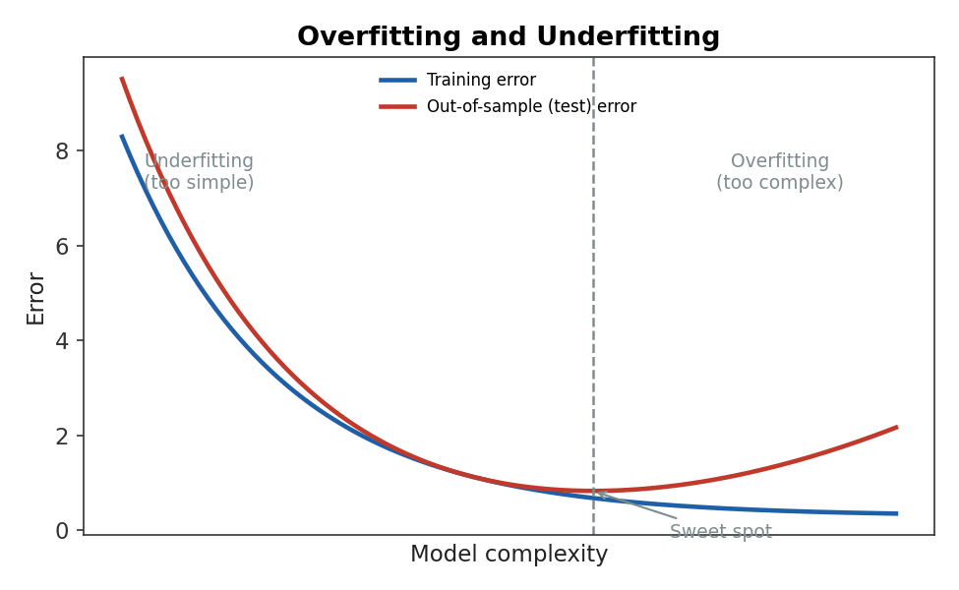
Figure 1.3 — As model complexity increases, training error falls monotonically, but out-of-sample (test) error falls only up to a point before rising again — the point of minimum test error is the appropriate level of complexity, not the point of minimum training error.
The diagnostic: large gap between train and test error ⇒ overfitting; both errors high ⇒ underfitting
Tip — Watch the gap, not just the level.
A model with mediocre but similar training and test performance is underfitting and may benefit from more flexibility, more features, or more training. A model with excellent training performance and much worse test performance is overfitting and needs simplifying, more data, regularisation, or stronger validation — not a more sophisticated architecture layered on top of the same problem.

Part 2 — Validation Schemes for Time-Series Data
The train/validation/test split of Part 1 is the right idea, but the standard way of implementing it in most of statistics and machine learning — random shuffling and k-fold cross-validation — is actively dangerous when applied to financial time series without modification. This part explains why, and covers the schemes built specifically for chronologically ordered data.

2.1 Why Standard Cross-Validation Fails on Time Series
Standard k-fold cross-validation randomly partitions data into k folds, trains on k−1 of them, and tests on the remaining fold, rotating through all k combinations. This works well when observations are independent and identically distributed. Financial time series are neither: observations are serially correlated, and — critically — a random partition will routinely place a test fold chronologically before some of the training data, meaning the model is effectively being tested using information from the future relative to that test period.
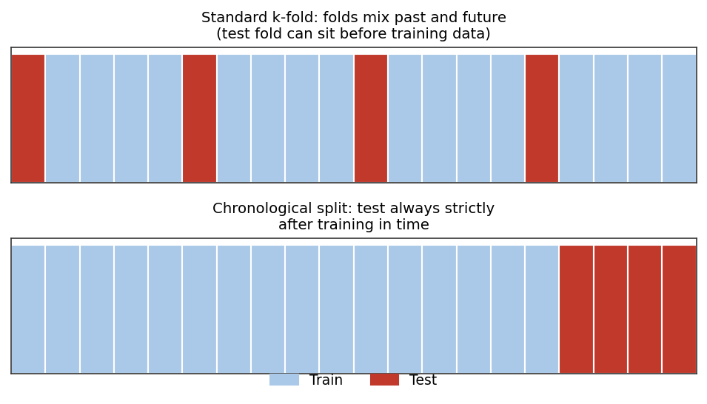
Figure 2.1 — Standard k-fold cross-validation (top) scatters test folds throughout the timeline, so training data from later periods can leak into predictions for earlier ones; a chronological split (bottom) keeps every test observation strictly after every training observation.
Common mistake — Randomly shuffling time-series observations when chronological ordering is required.
Shuffling breaks the one property a valid backtest depends on: that every prediction is made using only information available before the date it applies to. A model validated with shuffled time-series folds can show excellent cross-validated performance purely because it is allowed to “predict” the past using the future — a form of look-ahead bias built directly into the validation procedure itself, not just the model.

2.2 Walk-Forward Validation
Walk-forward validation respects chronological order by construction. The model is trained on all data up to a given point in time, tested on the period immediately following, and then the training window is rolled or expanded forward to include that period before testing on the next one — repeating this process across the full history. This produces a sequence of genuinely out-of-sample test periods that, taken together, closely mimic how the model would actually have been retrained and used in real time.
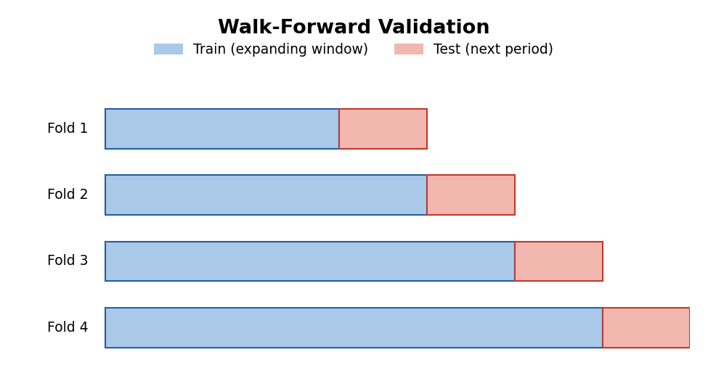
Figure 2.2 — Walk-forward validation trains on an expanding (or rolling) window and tests only on the period immediately following it, then moves forward — every test period is genuinely unseen at the time it would have been traded.
# Minimal walk-forward validation loop
import numpy as np

results = []
for fold_end in fold_boundaries: # chronologically increasing
train = data[data.date < fold_end]
test = data[(data.date >= fold_end) & (data.date < fold_end + test_window)]
model = fit_model(train) # retrain using only past data
preds = model.predict(test)
results.append(evaluate(preds, test.target)) # genuinely out-of-sample score

walk_forward_score = np.mean(results) # aggregate across all folds

Worked example — Expanding vs rolling windows.
An expanding window keeps all historical data in the training set as it grows (fold 1 trains on months 1–40, fold 2 on months 1–55, fold 3 on months 1–70, and so on), which uses the maximum available data at each step but can dilute a genuine recent regime change with a large volume of older, less relevant data. A rolling window instead keeps training-set length fixed and drops the oldest data as new data arrives (fold 1 trains on months 1–40, fold 2 on months 16–55, fold 3 on months 31–70), which adapts faster to regime change at the cost of using less data per fold. The right choice depends on how quickly the underlying relationship is believed to change.

2.3 Time-Series Cross-Validation, Purging, and Embargo (awareness)
Awareness-level: understand what purging and embargoing are for and why they matter, not how to select purge and embargo windows optimally for a novel dataset, which belongs to Depth 3+.
Even a chronologically ordered split can leak information if a feature or a label depends on a window of time that straddles the train/test boundary — for example, a label defined as “return over the next 20 days” computed near the end of the training set will overlap with the start of the test set. Purging removes training observations whose label window overlaps with the test period; embargoing adds a further buffer after the test period before the next training window begins, to prevent information from a serially correlated series bleeding backward across the boundary.
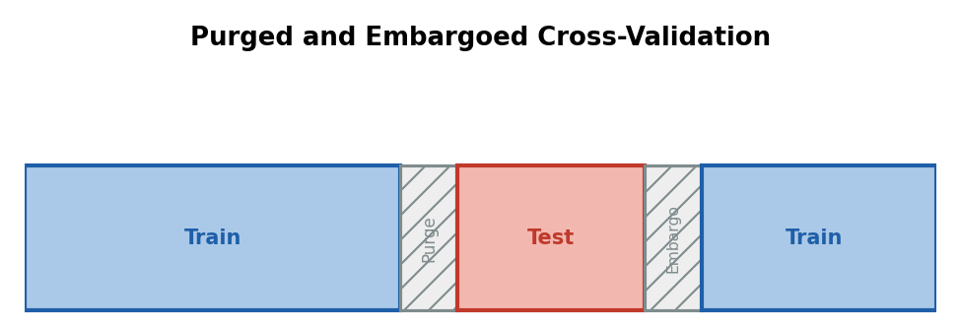
Figure 2.3 — A purge window removes training observations whose outcome overlaps with the test period; an embargo adds a buffer after the test period before subsequent training resumes — both prevent subtle boundary leakage in serially correlated data.
Prerequisite gate — Purging and embargoing are Depth 3+ implementation details.
At this level, the goal is to recognise that a chronological split alone does not automatically prevent all leakage when labels or features span multiple periods, and to know that purging and embargoing exist as the standard remedy. Choosing correct purge and embargo lengths for a specific label-construction scheme, and implementing Combinatorial Purged Cross-Validation, are Depth 3+ topics covered in Advanced Extensions.

Part 3 — Biases That Corrupt a Backtest
A validation scheme can be structurally correct — properly chronological, properly purged — and still produce a misleading result if the underlying dataset or feature pipeline contains one of a small number of well-known biases. This part covers the three that appear most often in quantitative finance.

3.1 Look-Ahead Bias
Look-ahead bias occurs when a backtest uses information that would not actually have been available at the time a decision was made. The classic example is using a company's reported earnings on the date they refer to, rather than the (later) date they were actually released to the public — or, worse, using a restated figure that was only corrected months afterward. Any such error causes the backtest to “know” things a real trader could not have known, systematically flattering performance.
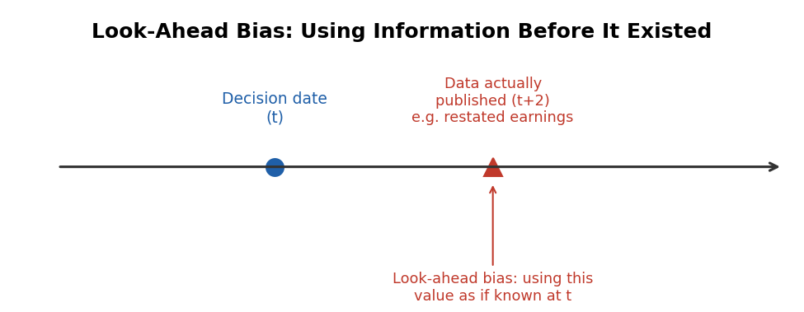
Figure 3.1 — A decision made on date t must use only information available by t; using a data point that was not actually published until a later date, as though it were known at t, is look-ahead bias.
Worked example — A subtle look-ahead error.
A backtest computes a monthly rebalancing signal using “this month's” GDP growth figure, applied on the first trading day of the month the figure describes. In reality, GDP figures for a given month are typically not released until three to five weeks after that month ends. The backtest is therefore trading on information that would not exist for another month — a look-ahead error that can be entirely invisible in the code (the column is correctly labelled and dated) while still fatally compromising the result.

3.2 Data Leakage
Data leakage is the broader category that look-ahead bias belongs to: any pathway by which information from outside the legitimate training set — commonly the test set, or the future — influences model training or feature construction. A particularly common and easy-to-miss form occurs during pre-processing: fitting a scaler, an imputer, or a feature-selection step on the entire dataset before splitting into train and test allows statistics from the test set (its mean, its variance, which features happened to correlate with the target) to influence the training process.
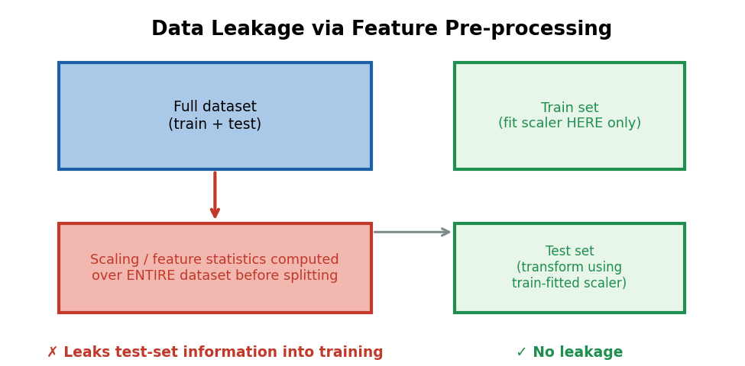
Figure 3.2 — Fitting a scaler or feature-selection step on the full dataset before splitting (left) leaks test-set statistics into training; fitting only on the training set and applying that same transformation to the test set (right) avoids it.
# WRONG: scaler fitted on the full dataset before splitting
scaler.fit(full_data)
full_scaled = scaler.transform(full_data)
train, test = split(full_scaled) # test-set statistics already leaked in

# RIGHT: scaler fitted on the training set only
train_raw, test_raw = split(full_data)
scaler.fit(train_raw) # fit using training data only
train = scaler.transform(train_raw)
test = scaler.transform(test_raw) # test set transformed, never seen by fit()

Common mistake — Allowing future information into feature construction, parameter estimation, or portfolio formation.
Leakage is rarely as obvious as literally including tomorrow's price as a feature. It more often hides in details such as: computing a cross-sectional z-score using the full universe's statistics on the rebalancing date (including securities whose data was only finalised later), using a covariance matrix estimated over a window that extends past the test period, or selecting which assets to include in a backtest based on criteria evaluated using their entire history, including the test period itself.

3.3 Survivorship Bias and Selection Bias
Survivorship bias arises when a historical dataset includes only entities — funds, companies, index constituents — that still exist today, silently dropping those that failed, were delisted, or were acquired. Because failure is correlated with poor historical performance, a survivors-only dataset systematically overstates average historical returns and understates historical risk, since the worst outcomes have been removed from the sample by construction rather than by any modelling choice.
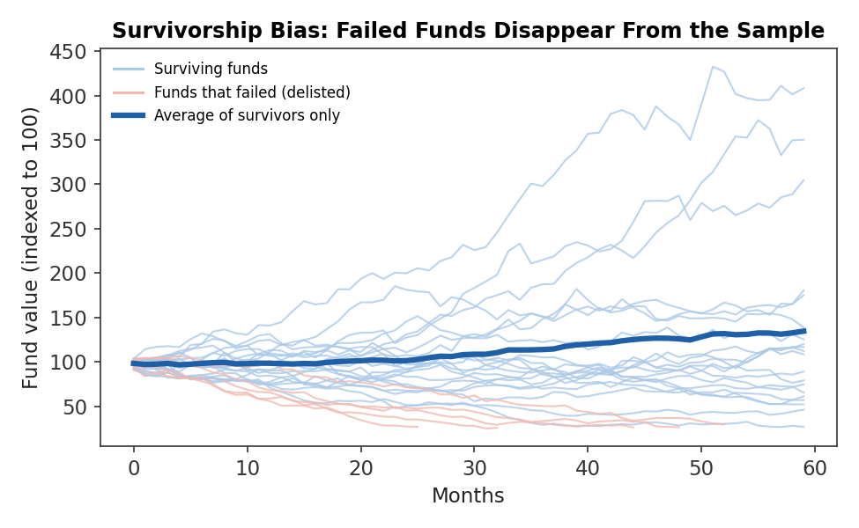
Figure 3.3 — Funds that failed and were delisted (red) disappear from a survivors-only dataset; averaging only the surviving funds (dark blue) overstates typical historical performance relative to the full original population.
Selection bias is the broader phenomenon: any systematic difference between the sample used for research and the population the model will actually be applied to, arising from how the sample was chosen rather than how the world behaves. A momentum strategy tested only on current S&P 500 constituents, for example, is implicitly conditioning on “having been successful enough to be in the S&P 500 today” — a selection criterion correlated with the very outcome being studied.
Tip — Ask where the dataset came from before trusting what it shows.
Point-in-time datasets — which record what the investable universe actually looked like on each historical date, including entities that have since disappeared — are the standard remedy for survivorship bias, and are worth the extra cost and complexity relative to a convenient but survivorship-biased alternative. If a data source cannot confirm it is point-in-time, assume it is not.

Part 4 — Statistical Validation: Significance and Resampling
A backtest produces a single number — a Sharpe ratio, a hit rate, an average return. Parts 1–3 covered how to make sure that number is measured on genuinely out-of-sample, unbiased data. This part covers a different question: given that number, how confident should you be that it reflects a real effect at all, rather than a plausible-looking outcome of chance?

4.1 Statistical Significance and Confidence Intervals
Statistical significance asks how unlikely an observed result would be if there were, in truth, no genuine effect — if the strategy's true expected return were exactly zero and the observed backtest performance arose purely from sampling variation. A confidence interval takes this further, providing a range of plausible values for the true underlying performance, constructed so that it would contain the true value a specified percentage of the time under repeated sampling.
Approximate 95% CI for a Sharpe ratio: SR̂ ± 1.96 × √((1 + SR̂²/2) / T)
where T is the number of independent return observations. The formula's shape carries an important lesson on its own: the width of the confidence interval shrinks only with the square root of T, so quadrupling the length of a backtest only halves the width of the uncertainty band around the estimated Sharpe ratio — short backtests produce estimates with far more uncertainty than their single reported number suggests.
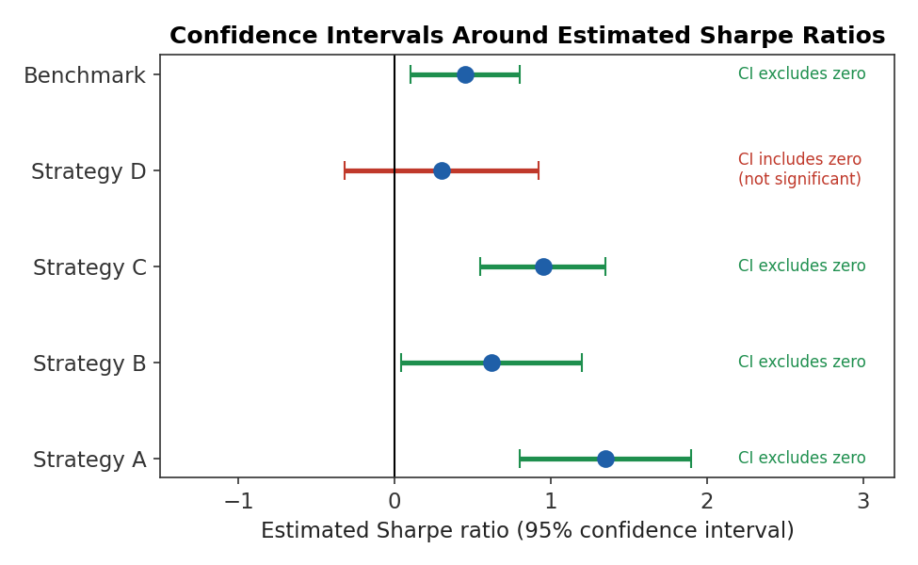
Figure 4.1 — Confidence intervals around several strategies' estimated Sharpe ratios. Strategy D's interval includes zero — its apparent edge is not statistically distinguishable from no edge at all, despite a positive point estimate.
Worked example — A Sharpe ratio that looks good but isn't significant.
A strategy backtested over 3 years of monthly returns (T = 36) reports an annualised Sharpe ratio of 0.60. Using the approximation above, the 95% confidence interval is roughly 0.60 ± 1.96×√((1+0.18)/36) ≈ 0.60 ± 0.35, i.e., approximately (0.25, 0.95). Because this range does not include zero, the result is (marginally) statistically significant — but the wide interval also means the true Sharpe ratio could plausibly be anywhere from mediocre to quite good, and a slightly shorter backtest or slightly noisier data could easily have produced an interval that did include zero.

Common mistake — Assuming a high Sharpe ratio automatically implies a robust strategy.
A high point estimate computed over a short history, a single market regime, or a small number of independent bets can carry enormous statistical uncertainty despite looking impressive. A Sharpe ratio should always be reported alongside some indication of its uncertainty — a confidence interval, a sample size, or a significance test — rather than as a bare number implicitly presented as exact.

4.2 Bootstrap Validation
The confidence-interval formula above relies on a theoretical approximation that assumes returns are close to normally distributed and independent — assumptions financial returns routinely violate through fat tails and autocorrelation. The bootstrap sidesteps this by resampling: repeatedly drawing new synthetic return series, with replacement, from the observed historical returns, recomputing the statistic of interest (Sharpe ratio, maximum drawdown, hit rate) on each resample, and building an empirical distribution directly from the results rather than assuming a theoretical shape.
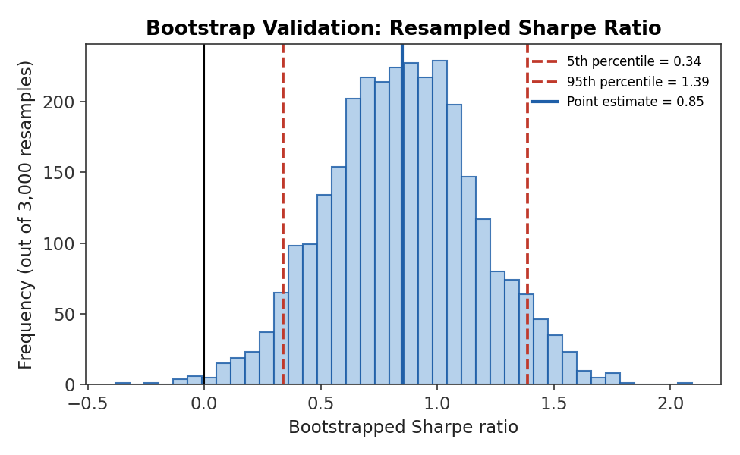
Figure 4.2 — A histogram of a strategy's Sharpe ratio recomputed across 3,000 bootstrap resamples of its historical returns, giving an empirical confidence interval (dashed lines) without assuming a particular theoretical distribution.
# Minimal bootstrap confidence interval for a Sharpe ratio
import numpy as np

returns = strategy_returns # historical return series, length T
n_boot = 3000
boot_sharpes = np.empty(n_boot)

for i in range(n_boot):
sample = np.random.choice(returns, size=len(returns), replace=True)
boot_sharpes[i] = sample.mean() / sample.std() * np.sqrt(252) # annualised

ci_lower, ci_upper = np.percentile(boot_sharpes, [5, 95])

Tip — Use a block bootstrap for autocorrelated returns.
The simple resampling shown above draws individual observations independently, which understates uncertainty when returns are autocorrelated — as most financial time series are, to some degree. A block bootstrap resamples contiguous blocks of consecutive observations instead of single points, better preserving the serial dependence structure of the original data and typically producing wider, more honest confidence intervals.

4.3 Permutation Tests
A permutation test asks a slightly different question than a confidence interval: not “how uncertain is my estimate,” but “how likely is a result this good to arise purely by chance, if there were truly no relationship at all between my signal and the outcome?” It answers this by repeatedly breaking the real relationship — typically by randomly shuffling the signal relative to the outcomes, or shuffling the sequence of trade labels — and recomputing the performance statistic on each shuffled version to build a distribution under the null hypothesis of no genuine effect.
Permutation p-value ≈ (# of shuffled results ≥ observed result) / (number of permutations)
Worked example — Interpreting a permutation test.
A signal's backtested Sharpe ratio is 0.75. The signal is shuffled relative to the returns 1,000 times, and the Sharpe ratio is recomputed each time, simulating what performance would look like if the signal carried no genuine information. Only 18 of the 1,000 shuffled versions produce a Sharpe ratio of 0.75 or higher purely by chance, giving a permutation p-value of 0.018 — suggesting the observed result would be unusual under the no-effect assumption, though this says nothing yet about transaction costs, capacity, or how many other signals were tried before this one (Part 6).

Part 5 — Benchmarks, Stability, and Robustness
A statistically significant result measured against a fixed set of parameters is still not the end of validation. This part covers three further checks: whether the model actually beats a sensible, simple alternative; whether its performance depends on a suspiciously narrow set of parameter choices; and whether it continues to work under reasonable variations to the testing setup.

5.1 Benchmark Models
A benchmark model is a simple, well-understood point of comparison against which a new model's added value must be judged — a naive forecast (tomorrow's price equals today's price), a market-capitalisation-weighted index, or a randomised strategy carrying the same risk exposure as the model under test. Reporting a model's absolute performance without a benchmark makes it impossible to tell whether the model is adding genuine value or simply capturing a risk premium, a market trend, or a level of risk that a much simpler approach would have captured just as well.
- Naive benchmarks — no-change forecasts, historical averages, or simple momentum/mean-reversion rules, useful for establishing the easiest bar a sophisticated model should clear.
- Market or index benchmarks — a relevant market index or factor portfolio, useful for establishing whether active management is adding value beyond simple market exposure.
- Risk-matched random benchmarks — randomised strategies constructed to carry the same volatility, leverage, or turnover as the model under test, useful for isolating skill from risk-taking.
Tip — Choose the benchmark before seeing the results, not after.
Selecting a benchmark after seeing how a model performed creates an obvious opportunity to choose whichever comparison makes the model look best. Committing to a benchmark — and, ideally, a full validation plan — before running the final test preserves the honesty of the comparison in the same way a genuinely untouched test set does.

5.2 Parameter Stability and Sensitivity Analysis
Most models involve choices — a lookback window, a signal threshold, a regularisation strength — selected by testing a range of values and picking whichever performed best historically. Parameter stability asks whether performance is reasonably good across a broad range of nearby parameter values (suggesting a genuine, robust effect) or whether it collapses sharply away from one specific, narrow combination (suggesting the “optimal” parameters were curve-fit to sample-specific noise).
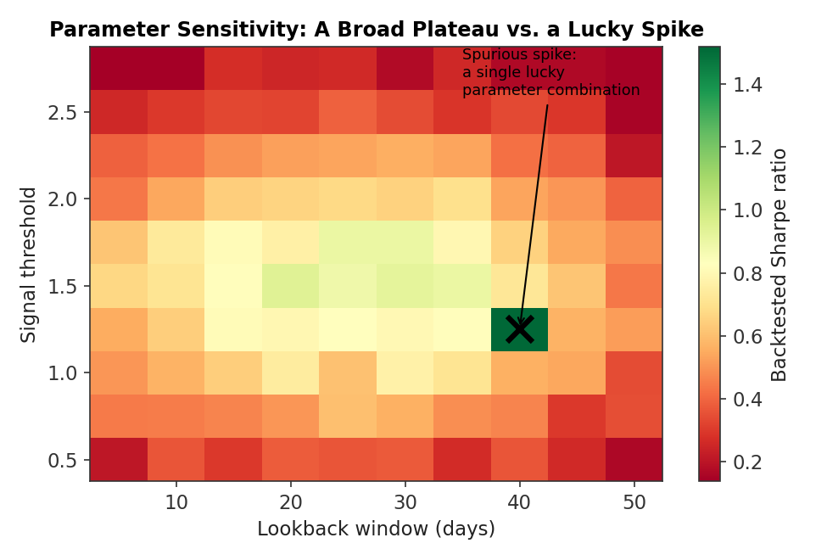
Figure 5.1 — A sensitivity heatmap across two parameters. Most of the grid shows a broad, gently varying plateau of reasonable performance, except for one isolated spike — a strong signal that the spike is a lucky, unstable combination rather than a genuinely superior parameter choice.
Common mistake — Selecting the best-performing model from many experiments without accounting for multiple testing.
Testing a wide grid of parameter combinations and reporting only the single best result is mathematically similar to running many independent statistical tests and reporting only the one that happened to come out significant — the more combinations tried, the more likely one will look good by chance alone, regardless of whether any genuine effect exists. Sensitivity analysis (examining the whole grid, not just its maximum) and the multiple-testing corrections introduced in Part 6 are both necessary responses to this same underlying problem.

Common mistake — Failing to examine parameter sensitivity and assuming the optimal combination is uniquely meaningful.
Treating the single best-performing parameter combination as if it revealed something economically special about, say, a 47-day lookback specifically — rather than as the peak of a noisy surface that could plausibly have peaked at 40 or 55 days with a slightly different sample — is a direct route to deploying a fragile, curve-fit model in place of a genuinely robust one.

5.3 Robustness Testing
Robustness testing extends sensitivity analysis beyond parameters to the broader assumptions embedded in a backtest: does the result hold under a different universe of assets, a different data vendor, a different definition of the outcome variable, a different transaction-cost assumption, or a different historical sub-period? A result that survives these perturbations is far more likely to reflect a genuine, exploitable relationship than one that depends on one specific, unexamined set of choices.
- Sub-period robustness — does the strategy perform reasonably across multiple distinct historical periods, rather than being driven entirely by one unusually favourable stretch?
- Universe robustness — does the result hold on a related but distinct set of assets, or is it specific to the exact securities originally tested?
- Assumption robustness — does the result survive reasonable changes to transaction-cost assumptions, rebalancing frequency, or the precise definition of the signal or label?
Common mistake — Validating only over a single market regime or unusually favourable historical period.
A strategy backtested only over a strong bull market, only over a low-volatility regime, or only over a period that happens to exclude a major crisis can show excellent performance that has never actually been tested against the conditions most likely to reveal its weaknesses. Wherever possible, validation should deliberately include multiple, distinct market regimes — not merely the longest convenient sample.

Part 6 — Multiple Testing, Model Decay, and Ongoing Validation
This closing part addresses two realities that every preceding technique in this module is, in some sense, defending against: the fact that research is rarely a single test of a single idea, and the fact that even a genuinely validated model's edge is not guaranteed to last.

6.1 Multiple Testing and Data-Snooping (awareness)
Awareness-level: understand why testing many ideas inflates the chance of a false positive and that formal corrections exist, not how to compute a Deflated Sharpe Ratio or a Probability of Backtest Overfitting from scratch, which belongs to Depth 3+.
Every technique covered so far — chronological splits, purging, bootstrap confidence intervals, permutation tests — validates a single strategy against a single, pre-specified test. In practice, quantitative research rarely stops at one strategy: teams test dozens, hundreds, or (across an entire research organisation over time) many thousands of variations, and only the best-performing ones are written up, reviewed, and proposed for live trading. This process, sometimes called data-snooping, inflates the apparent significance of whatever survives, because the standard significance thresholds assume a single test was run, not the best of many.
Intuition: with 100 genuinely random strategies tested at a 5% significance threshold, roughly 5 will appear “significant” by chance alone
The Probability of Backtest Overfitting and the Deflated Sharpe Ratio (Advanced Extensions) are specifically designed to correct for this: rather than asking whether a single strategy's Sharpe ratio is significant in isolation, they ask what threshold a result needs to clear given how many strategies, parameter combinations, or variations were actually tried before arriving at the reported one.
Prerequisite gate — Multiple-testing corrections are Depth 3+ statistical machinery.
At this level, the essential habit is honestly tracking and disclosing how many models, features, or parameter combinations were tried during research — not the specific formula used to adjust for it. A validation report that states a strategy's Sharpe ratio without mentioning that it was the best of 200 candidates tested is materially incomplete, regardless of how rigorous the walk-forward and bootstrap analysis behind that single number was.

6.2 Model Decay and Out-of-Sample Performance
Model decay is the tendency of a model's live or ongoing out-of-sample performance to deteriorate over time relative to its original backtest. Decay can arise from a genuinely changing market regime, from crowding as other participants discover and exploit the same or a similar signal, from the original relationship having been partly a statistical artefact that only fully reveals itself given enough additional data, or from the world genuinely changing in ways the original training data could not have anticipated.
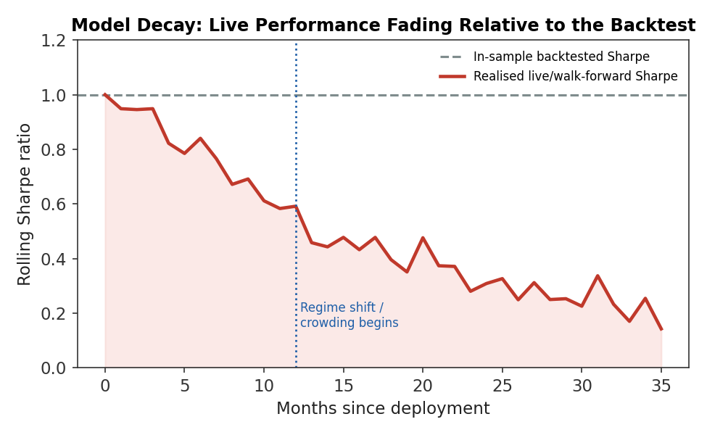
Figure 6.1 — A model's rolling live Sharpe ratio fading well below its original in-sample backtest over the months following deployment — the pattern that ongoing, walk-forward-style monitoring is designed to detect early.
Because decay is expected to some degree even for genuinely well-validated models, the appropriate response is not to treat any decline as proof the model was always flawed, but to build ongoing monitoring directly into the deployment process: tracking live performance against the walk-forward performance the validation process predicted, watching for the point at which a decline becomes large or persistent enough to warrant retraining, recalibration, or retirement, rather than waiting for a single bad quarter to force the question.
Tip — Treat deployment as the start of validation, not the end of it.
The walk-forward performance measured during research is a forecast of how a model will behave live, not a guarantee. Comparing realised live performance against that walk-forward forecast, on an ongoing basis, is the only way to tell early whether a model is behaving as validated or has begun to decay — and is a core part of the model-monitoring responsibilities introduced in Professional Applications below.

Practical Exercise
Develop a simple predictive trading model using historical market data. Compare in-sample, validation, and strictly out-of-sample performance using a walk-forward framework. Test for look-ahead bias and data leakage, incorporate transaction costs and slippage, and evaluate whether the model's performance remains statistically and economically significant across different market regimes.

Suggested approach
- Build a simple signal (e.g., a moving-average crossover or a simple regression-based forecast) and split the data chronologically into training, validation, and test segments before touching the test segment at all.
- Implement a walk-forward loop that retrains the model on an expanding window and tests only on the immediately following period, aggregating results across all folds rather than relying on a single split.
- Deliberately introduce, then remove, a look-ahead error (e.g., using same-day rather than next-day data) and a leakage error (e.g., fitting a scaler on the full dataset) to observe how much they inflate apparent performance.
- Apply a bootstrap or permutation test to the walk-forward results to assess statistical significance, and produce a parameter-sensitivity heatmap across at least two parameters to check for a stable plateau versus a lucky spike.
- Split the out-of-sample period into at least two distinct sub-periods (e.g., differing volatility regimes) and compare performance across them.
# Skeleton for the practical exercise
import numpy as np, pandas as pd

train, val, test = chronological_split(data, ratios=[0.6, 0.2, 0.2])

# 1. Fit and tune using only train + validation
model = fit_model(train)
best_params = tune_on_validation(model, val)

# 2. Walk-forward evaluation across the full history
wf_scores = []
for fold_end in fold_boundaries:
tr = data[data.date < fold_end]
te = data[(data.date >= fold_end) & (data.date < fold_end + test_window)]
m = fit_model(tr, params=best_params)
wf_scores.append(evaluate_with_costs(m.predict(te), te))

# 3. Bootstrap confidence interval on the walk-forward Sharpe ratio
boot = [np.random.choice(wf_scores, len(wf_scores), replace=True).mean() for _ in range(2000)]
ci = np.percentile(boot, [5, 95])

# 4. Only now, once, evaluate the untouched test set for a final check
final_score = evaluate_with_costs(model.predict(test), test)

Common Beginner Mistakes
- Reporting in-sample performance as evidence that a model works.
- Randomly shuffling time-series observations when chronological ordering is required.
- Allowing future information to enter feature construction, parameter estimation, or portfolio formation.
- Repeatedly modifying a strategy after seeing test-set results, effectively turning the test set into another training set.
- Ignoring transaction costs, bid-ask spreads, slippage, market impact, and liquidity.
- Selecting the best-performing model from hundreds of experiments without accounting for multiple testing and data-snooping bias.
- Assuming a high Sharpe ratio automatically implies a robust strategy.
- Validating only over a single market regime or unusually favourable historical period.
- Failing to examine parameter sensitivity and assuming the optimal parameter combination is uniquely meaningful.

Advanced Extensions
The following are Depth 3+ topics, introduced here only by name so you know what to look for when you reach them:
- Purged and embargoed cross-validation, and Combinatorial Purged Cross-Validation (CPCV) — systematic frameworks for generating many valid, non-overlapping train/test combinations from a single time series without leakage.
- Probability of Backtest Overfitting (PBO) and the Deflated Sharpe Ratio — formal statistical corrections for having tested many strategies or parameter combinations before selecting the reported one.
- White's Reality Check and Hansen's Superior Predictive Ability (SPA) test — formal hypothesis tests for whether the best of many candidate strategies genuinely outperforms a benchmark, accounting for the search itself.
- Multiple-hypothesis correction (e.g., Bonferroni, Benjamini-Hochberg) — general statistical techniques for controlling false-positive rates when many tests are conducted simultaneously.
- Bootstrap methods for dependent (autocorrelated) returns, including the block bootstrap and stationary bootstrap, beyond the simple i.i.d. bootstrap introduced in this module.
- Nested walk-forward optimisation, adversarial validation, regime-conditional validation, online validation, and concept-drift detection — more advanced schemes for validating models whose environment or optimal parameters may themselves be changing (Level 5).
- Model monitoring and recalibration — formal frameworks for detecting and responding to model decay in a live production system.

Professional Applications
- Strategy research and alpha validation — determining whether a proposed signal or strategy has genuine, statistically defensible predictive value before it consumes further research resources.
- Systematic trading — building walk-forward and monitoring infrastructure directly into a systematic strategy's lifecycle, from initial research through live deployment.
- Model risk management and model approval — independent review processes, common at banks and large asset managers, that formally assess a model's validation evidence before authorising its use with real capital.
- Portfolio construction and risk-model validation — applying the same out-of-sample discipline to covariance and risk estimates feeding into the Optimisation module, not only to return-forecasting models.
- Backtesting infrastructure — building and maintaining shared, leakage-resistant backtesting systems that enforce chronological splits and point-in-time data by default, rather than relying on individual researchers to avoid every pitfall manually.
- Ongoing model monitoring and performance attribution — tracking live performance against walk-forward expectations, detecting decay early, and attributing any shortfall to identifiable causes (regime change, crowding, execution costs) rather than treating it as unexplained noise.

Where to Go Next
This module deliberately stopped at awareness-level for purged and embargoed cross-validation, multiple-testing corrections, and the full range of Advanced Extensions above. Depth 3+ of this same module returns to each of them quantitatively — with explicit derivations, implementations of CPCV and the Deflated Sharpe Ratio, and calibration exercises — and is the appropriate next stop before attempting to design or operate a production model-approval framework, per the prerequisite gates throughout this guide. From there, the curriculum's Optimisation and Risk Metrics modules depend directly on the validated forecasts and risk estimates this module is designed to certify.

